Chapter 19, Problem 2.

Find the impedance parameter equivalent of the network in Fig.19.66.

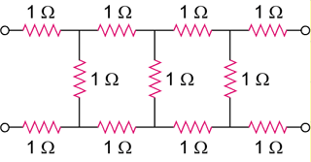

Figure 19.66
For Prob. 19.2.

